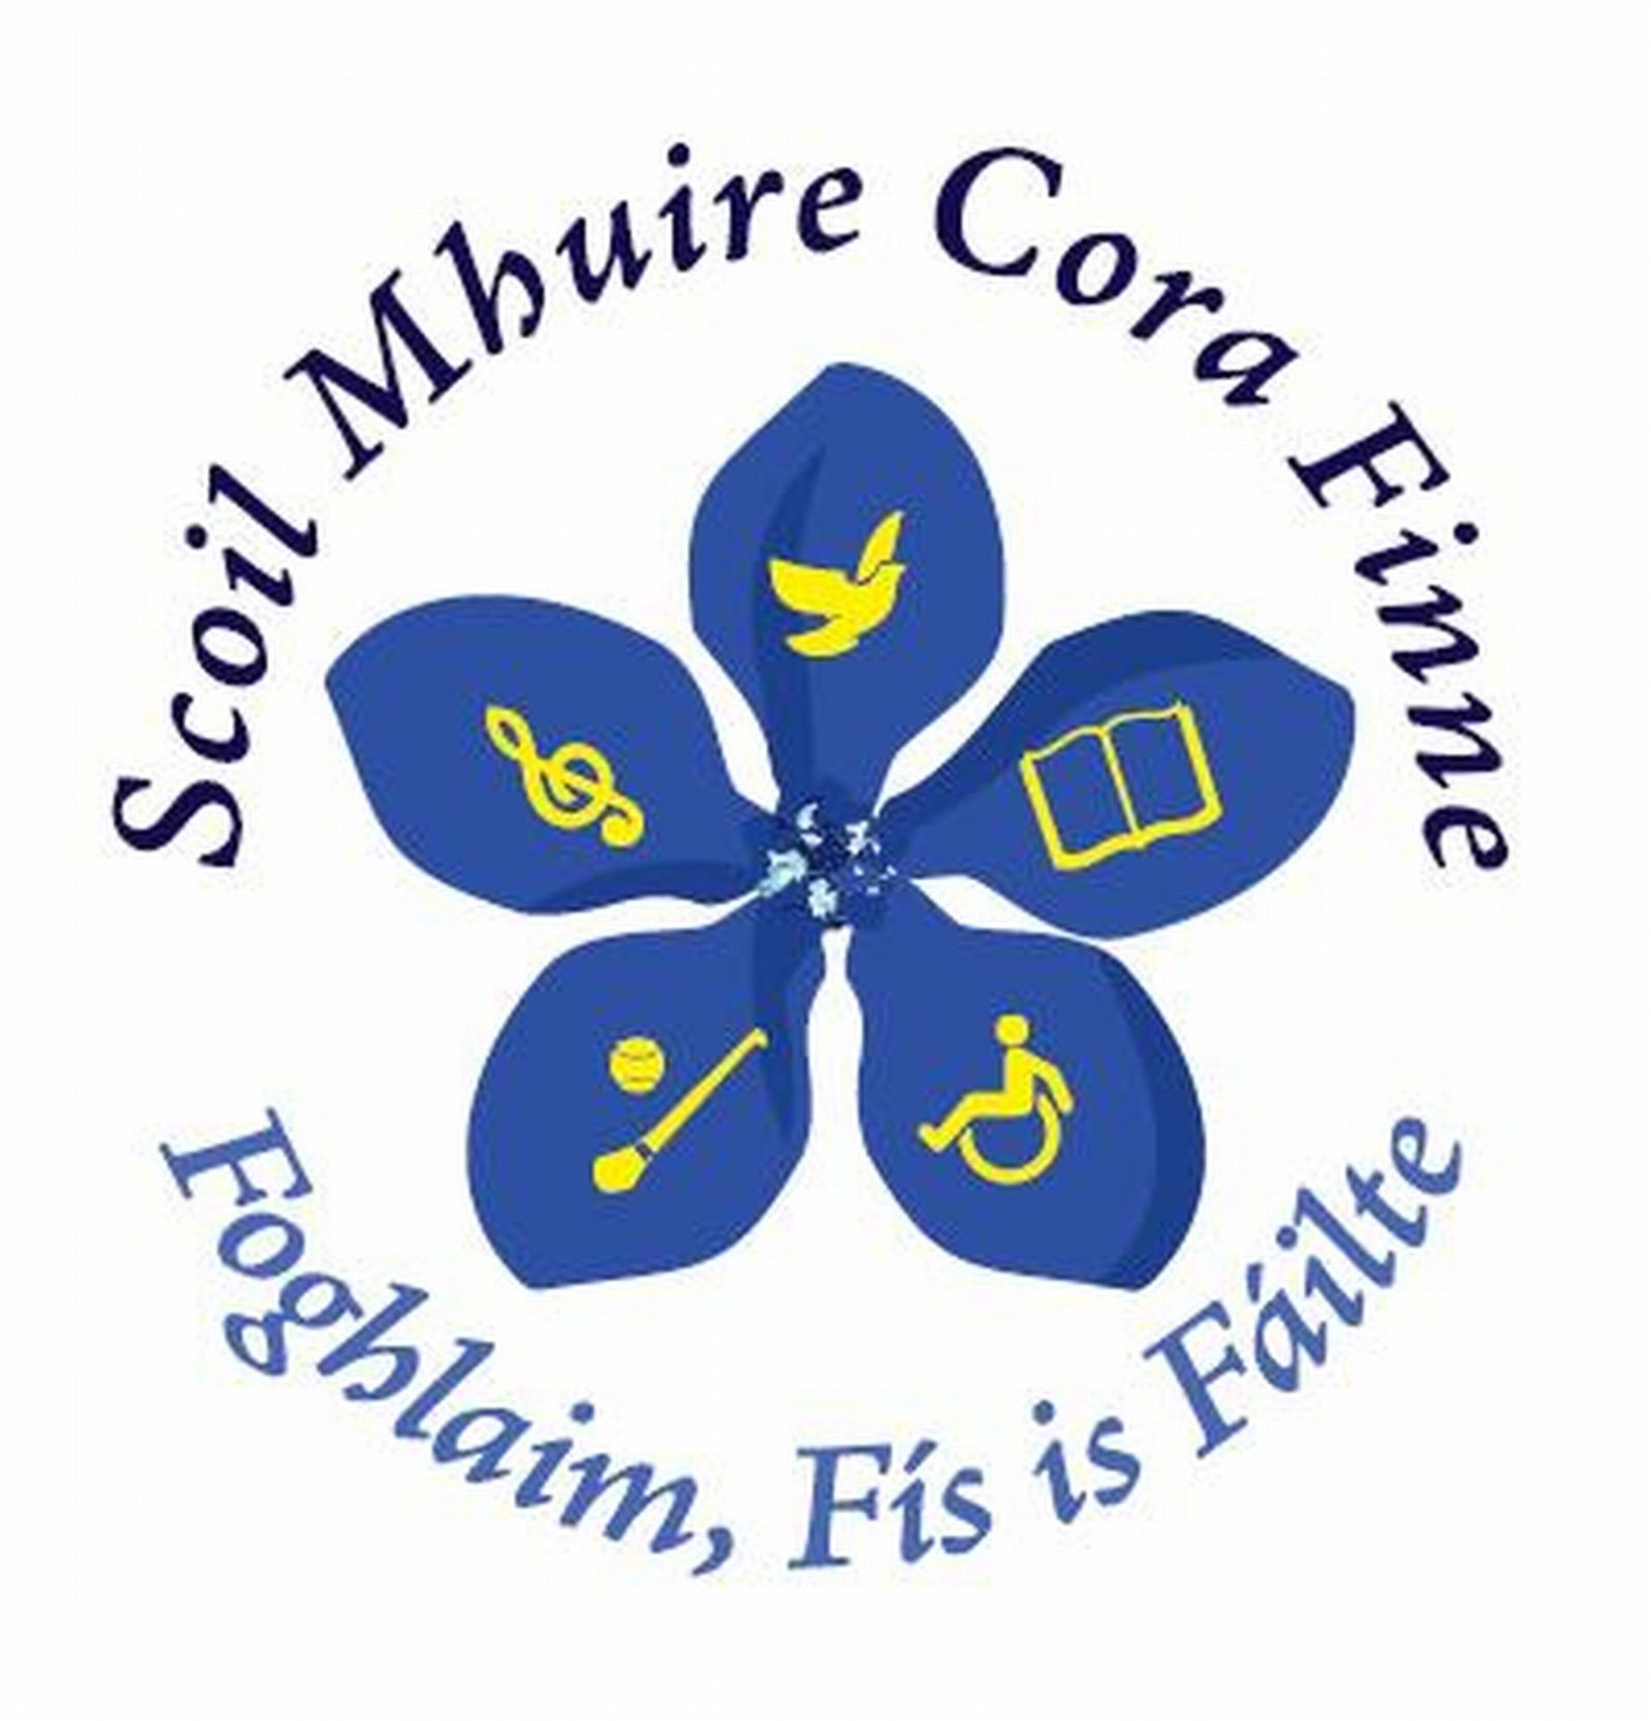

School
Self
Evaluation
Report

Gaeilge

Scoil Mhuire
Corofin

School Self-evaluation Report
Gaeilge
Evaluation Period:
September 2014 – September 2018

School Self Evaluation Report

- Introduction

  - A school self-evaluation of teaching and learning was
undertaken in Scoil Mhuire, Cora Finne during the period Sept. 2014 – June 2018. During the evaluation, the teaching and learning of Irish was undertaken.

The following is a report on the findings of the evaluation:

  - School Context

- Scoil Mhuire is a Catholic School in the Diocese of Killaloe. It is a mixed rural school with 7 members of staff including the Principal (5 classroom teachers, 1 learning support and one Resource teacher).

- There are 123 children on roll. The school participates in various local events and competitions such as ‘Feile na
h-Inse’ and ‘Seachtain na Gaeilge’ and Aifreann Lá le Pádraig.

- The school administers Drumcondra Spelling, Micra T and Sigma T standardised tests in Mathematics and English from Senior Infants to 6th class, M.I.S.T. in Infants and NRIT to pupils in 2nd class and/or as required.

- Current Literacy & Numeracy initiatives in the school include the development of ICT in teaching and learning, Accelerated Reader, 1st steps writing programme, development of problem solving skills, attendance at problem solving CPD courses, numeracy & Literacy link training, numeracy & Literacy link support group attendance and attendance at “Scratch” computer courses.

- The Findings

- The teachers use various strategies and teaching methods in the classroom. The children are active learners with good communication between the teaching staff and the children during classes.
- Various evaluation methods are used regularly to chart the pupils’ progress.
- Teachers acknowledge that an improvement in the standard of oral Irish is necessary and consequently a whole school plan in this respect is recommended.
- There are pressures on teachers due to pupil numbers, lack of space and multiclass situations.
- According to the Pupil Survey,
- 83% like Irish
- 42% like reading
- 26% like writing
- 32% like speaking
- 73% consider that they are “good” at reading
- 71% consider that they are “good” at writing
- 64% think that they are “good” at speaking
- 36% consider Irish to be difficult
- 27% acknowledged that they did not get the opportunity to partake in group work yet.
- The teachers acknowledge that the children require further listening and speaking opportunities.
- The teachers were not in a position to make a comparison with national norms because standardised testing had not been undertaken in the school up to this point.

Sources: Teacher observation, discussion and analysis – Scot Analysis, Pupil
Questionnaire, sample checklist for Evaluation of Gaeilge.

- Progress made on improvement targets previously identified

Improvement targets were not identified so far. This is the first year of School Self-evaluation in Irish.

- Summary of Conclusions of School Self-Evaluation

  - Our school has strengths in the following areas:

- There are strong Irish traditions in our locality e.g. St. Patrick’s Day Mass.
- The teachers are interested in Irish and some parents show interest in the language.
- The teachers use ‘Seachtain Óg’ (weekly Irish Indepentent supplement) as a teaching aid and they take part in activities for Seachtain na Gaeilge.
- The teachers understand the importance of digital media for teaching and learning and endeavour to incorporate it in their daily teaching.
- 73% of pupils describe themselves as a “good” reader in Irish
- 71% of pupils describe themselves as “good” at writing in Irish
- 64% of pupils describe themselves as “good” at speaking in Irish

  - The following areas are prioritised for improvement:

- Oral Irish – Informal Irish to be developed
- Functional language to be taught specifically.
- Suitable Irish schemes to be investigated and implemented.
- Group work/pair work to be organised in class to encourage communication.
- To improve capacity of the pupils in the areas of listening, oral expression and writing.
- Formal assessments in Irish to be introduced.
- Incorporate Irish as a living language in other subjects – introduce P.E. warm ups “as gaeilge”.
- Use of digital media as teaching and learning aids.
- School Irish plan to be reviewed.

  - Regulatory requirements addressed

Data protection and retention policy to be updated 2016-2017

